Access FlexPLM.

In the sidebar expand the season tab and in the drop down select the season you wish to add a plan for.

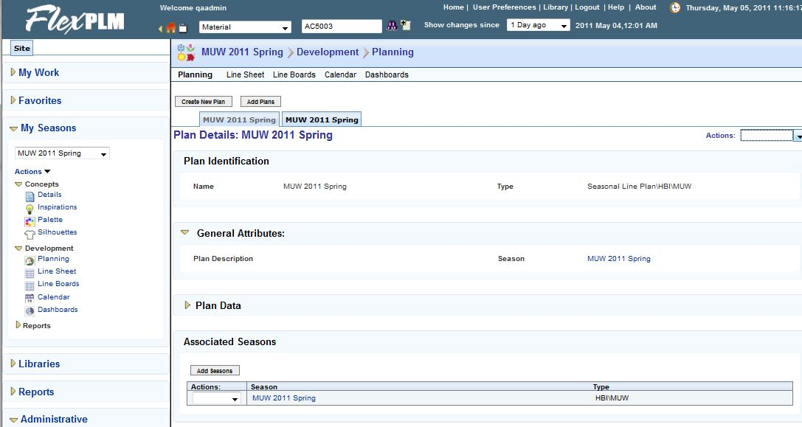

Select the planning link

In the actions menu select update plan.

Select the + block in the row you wish to add a group below. 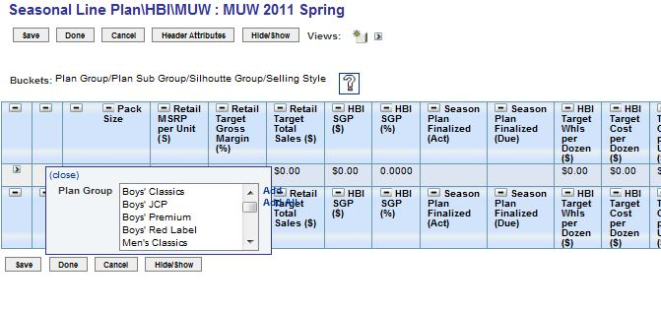

Select the groups you wish to add then click the add link.

Select the + block next to the group that you wish to add a sub group too.

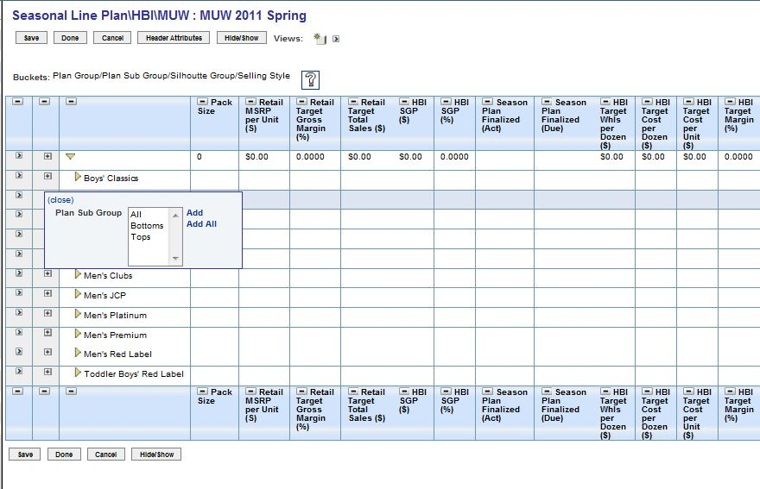

Select the sub groups you wish to add then click the add link. Select the save button then the done button.